**A PRELIMENERY REPORT ON**

**EFFICIENT FARMER TO CONSUMER WEB APP**

SUBMITTED TO THE MUMBAI UNIVERSITY, MUMBAI IN THE PARTIAL FULFILLMENT OF THE REQUIREMENTS FOR THE AWARD OF THE DEGREE

OF

# BACHELOR OF ENGINEERING (INFORMATION TECHNOLOGY)

**SUBMITTED BY**

MR. KADAM DARSHAN BALASAHEB (UID 121IT3236A)

MR. NIPANE ARYAN SANJAY (UID 120IT1228A)

MR. PAWAR HERSCHEL PRAVIN (UID 120IT1108A)

MR. THORAT MANISH SANTOSH (UID 120IT1006A)

Under the Guidance of

**Prof. Madhuri Patil**

# DEPARTMENT OF INFORMATION TECHNOLOGY

# MGM’S COLLEGE OF ENGINEERING AND TECHNOLOGY

**NAVI MUMBAI, KAMOTHE – 410210**

**MUMBAI UNIVERSITY**

**A.Y. 2023 - 2024**



## CERTIFICATE

This is to certify that the Project report entitled

“**EFFICIENT FARMER TO CONSUMER WEB APP**”

Submitted by

MR. KADAM DARSHAN BALASAHEB (UID 121IT3236A)

MR. NIPANE ARYAN SANJAY (UID 120IT1228A)

MR. PAWAR HERSCHEL PRAVIN (UID 120IT1108A)

MR. THORAT MANISH SANTOSH (UID 120IT1006A)

is a bonafide student of this institute and the work has been carried out by him/her under the supervision of **Prof. Madhuri Patil** and it is approved for the partial fulfillment of the requirement of Mumbai University, for the award of the degree of **Bachelor of Engineering** (Information Technology).

**Prof. Madhuri Patil**

Guide

Department of Information Technology

**Dr. Swati Sinha Dr. Geeta S. Lathkar**

Head Director

Department of Information Technology MGMCET, Navi Mumbai

## PROJECT REPORT APPROVAL

This Project entitled “**EFFICIENT FARMER TO CONSUMER WEB APP**” by **MR. KADAM DARSHAN BALASAHEB (UID 121IT3236A), MR. NIPANE ARYAN SANJAY (UID 120IT1228A), MR. PAWAR HERSCHEL PRAVIN (UID 120IT1108A), MR. THORAT MANISH SANTOSH (UID 120IT1006A)** is approved for the degree of Bachelor of Engineering in Information Technology.

**Examiners**

### 1.……………………………………

External Examiner

**2……………………………**

Internal Examiner

Place: Kamothe Date:

## DECLARATION

We declare that this written submission represents our ideas in our own words and where other’s ideas or words have been included, we have adequately cited and referenced the original sources. We also declare that we have adhered to all principles of academic honesty and have not misrepresented or fabricated or falsified any idea/data/fact/source in our submission. We understand that any violation of the above will be cause for disciplinary action by the institute and can also evoke penal action from the source which has thus not been properly cited or from whom proper permission has not been taken when needed.

|  |  |  |  |
| --- | --- | --- | --- |
| Sr. No. | Name of Student | UID | Signature |
| 1. | MR. KADAM DARSHAN BALASAHEB | UID 121IT3236A |  |
| 2. | MR. NIPANE ARYAN SANJAY | UID 120IT1228A |  |
| 3. | MR. PAWAR HERSCHEL PRAVIN | UID 120IT1108A |  |
| 4. | MR. THORAT MANISH SANTOSH | UID 120IT1006A |  |

Place: Kamothe Date:

## ACKNOWLEDGEMENT

The success and outcome of this project required a lot of guidance and assistance from many people and we are extremely fortunate to have got this all along with the completion of our project work. Whatever we have done is only due to such guidance and assistance and we would not forget to thank them. It is a matter of great pleasure for us to submit the project report on “**EFFICIENT FARMER TO CONSUMER WEB APP**” as a part of our curriculum.

First and foremost, we would like to thank our Director Dr. Geeta S. Lathkar, for giving us an opportunity to do the project work. We would like to thank our H.O.D and teachers for the valuable guidance and advice. To inspire us greatly to work on this project and willingness to motivate us contributed tremendously to our project.

And finally, a special thanks goes to my team members, who helped me to assemble the information and gave suggestions to complete our project.

|  |
| --- |
| **MR. KADAM DARSHAN BALASAHEB** |
| **MR. NIPANE ARYAN SANJAY** |
| **MR. PAWAR HERSCHEL PRAVIN** |
| **MR. THORAT MANISH SANTOSH** |

# ABSTRACT

This paper introduces a MERN stack-based web platform designed to connect farmers, consumers, and sellers, with the primary aim of facilitating direct exchanges of agricultural products. The platform enables farmers to list and promote their produce, consumers to browse and purchase locally-sourced items, and sellers to market agricultural supplies. The MERN stack technology ensures scalability and responsiveness, offering a user-friendly interface for all participants.

The website's core objective is to eliminate intermediaries in the agricultural supply chain, fostering more efficient and transparent transactions. By promoting direct sales and reducing overhead, this platform empowers farmers, benefits consumers with access to fresh local products, and offers sellers a dedicated agricultural clientele. The potential impact includes a more sustainable, equitable food system and improved agricultural sustainability.

In summary, this paper presents a technology-driven solution to bridge the gap between farmers, consumers, and sellers in the agricultural market, offering a user-friendly and efficient platform to promote direct transactions and enhance the quality and sustainability of the agricultural supply chain.

# TABLE OF CONTENTS

|  |  |  |
| --- | --- | --- |
| **Chapter No.** | **Title** | **Page No.** |
|  | **List of Figures** | **i** |
| **1** | **Introduction** | **1** |
| 1.1 | Purpose | **2** |
| 1.2 | Scope | **4** |
| **2** | **Literature Survey** | **5** |
| **3** | **Software Requirements Specifications** | **7** |
| **3.1** | **Introduction** | **7** |
|  | 3.1.1 Project Scope | **7** |
|  | 3.1.2 Assumptions and Dependencies | **7** |
| **3.2** | **Functional Requirements** | **9** |
| **3.3** | **Non-Functional Requirements** | **9** |
|  | 3.3.1 Performance Requirements | **9** |
|  | 3.3.2 Safety Requirements | **9** |
|  | 3.3.3 Security Requirements | **9** |
|  | 3.3.4 Software Quality Attributes | **9** |
| **4** | **Design & Implementation** | **10** |
| 4.1 | Software Analysis | **11** |
| 4.2 | Database ER-Diagram | **11** |
| 4.3 | Flowchart | **12** |
| **5** | **Conclusion and Future Works** | **18** |
| **6** | **References** | **19** |

**List of Figures**

|  |  |  |
| --- | --- | --- |
| **Fig.No** | **Title** | **Pg. No** |
| **1.1** | Database ER-Diagram | **8** |
| **1.2** | Flowchart | **9** |
| **1.3** | Flowchart cont. | **10** |
| **1.4** | Front Page | **11** |
| **1.5** | Products Page | **11** |
| **1.6** | Product Details Page | **12** |
| **1.7** | Cart Page | **13** |
| **1.8** | Address Input | **13** |
| **1.9** | Payment Methods | **14** |

# CHAPTER 1

# INTRODUCTION

The agricultural sector, a cornerstone of human civilization, is currently at the cusp of significant transformation, driven by the confluence of technology and evolving consumer preferences. In recent years, there has been a discernible shift in how agricultural products reach consumers. The traditional model, characterized by a convoluted and often inefficient supply chain with multiple intermediaries, is making way for a more direct, digitally-infused approach. This shift arises from the increasing demand for fresh, locally-sourced products and a growing awareness of the environmental and economic benefits associated with reduced supply chain complexity.

In response to these evolving demands, a novel web platform has emerged as a key player, leveraging the capabilities of the MERN stack (MongoDB, Express, React, Node.js). This platform is designed to address the critical challenge of bridging the gap between three integral players in the agricultural ecosystem: farmers, consumers, and sellers. By fostering direct interactions and transactions among these stakeholders, it aims to optimize the exchange of agricultural products while promoting transparency, trust, and sustainability within the sector.

The platform's central function is to provide an online marketplace where farmers can showcase their produce and connect directly with consumers. By doing so, it removes the need for intermediaries, thus streamlining the agricultural supply chain. This approach has far-reaching implications, not only in terms of boosting the economic prospects of farmers but also in granting consumers access to a wide range of fresh, locally-sourced agricultural products. Furthermore, the platform extends its reach to sellers, who offer an assortment of essential agricultural supplies, including seeds, equipment, livestock, and dairy products.

Within the context of this paradigm shift, the MERN stack, comprising MongoDB, Express, React, and Node.js, emerges as a technological bedrock that underpins the platform's robust functionality. MongoDB, as a database system, facilitates the efficient storage and management of diverse data associated with agricultural products and transactions. Express and Node.js provide the necessary server-side framework, while React offers an intuitive and responsive user interface, ensuring the scalability and adaptability required to accommodate the dynamic and multifaceted agricultural market.

This paper dives into the development and implications of this innovative web platform, offering a comprehensive understanding of how technology can reshape and revitalize the agricultural sector. The aim is not just to connect farmers with consumers, but also to empower agricultural suppliers and promote an efficient, transparent, and sustainable food supply chain. As we delve deeper into the nuances of this transformative endeavor, it becomes evident that the platform has the potential to drive the growth of the agricultural sector, improve access to high-quality, locally-sourced agricultural products, and bolster the sustainability of the agricultural ecosystem as a whole.

## PURPOSE

The primary purpose of this research paper is to comprehensively explore and elucidate the development and potential impact of an innovative web platform designed to facilitate direct interactions and transactions among farmers, consumers, and sellers within the agricultural ecosystem. This purpose can be further broken down into the following specific objectives:

1. Platform Development: To provide an in-depth understanding of the technical underpinnings of the web platform, with a particular focus on the use of the MERN stack, including MongoDB, Express, React, and Node.js, and its role in enabling a user-friendly interface for all participants.
2. Stakeholder Engagement: To examine the distinct roles and interactions of the three primary stakeholders - farmers, consumers, and sellers - within the platform, showcasing how it enables each of them to benefit from a more direct and efficient agricultural market.
3. Supply Chain Streamlining: To highlight the role of the platform in reducing intermediaries and streamlining the agricultural supply chain, ultimately resulting in more efficient and transparent transactions.
4. Economic Empowerment: To assess the economic implications of the platform, specifically how it empowers farmers by allowing them to reach a broader consumer base, potentially increasing their income and profitability.
5. Consumer Access: To investigate how the platform benefits consumers by providing them with access to fresh, locally-sourced agricultural products, promoting the consumption of healthier and more sustainable food choices.
6. Sustainability and Transparency: To underscore the potential impact of the platform in fostering greater sustainability and transparency within the agricultural sector, with a focus on promoting environmentally conscious agricultural practices.
7. Supplier Support: To shed light on how the platform accommodates agricultural suppliers, who play a crucial role in ensuring farmers have access to the necessary tools, equipment, and resources for a thriving agricultural enterprise.

## SCOPE

This research paper focuses on a multifaceted exploration of an innovative web platform connecting farmers, consumers, and sellers in the agricultural sector. The scope includes:

1. Technical Aspects:
   * In-depth analysis of the MERN stack's role in platform development.
   * Examination of the platform's technical architecture and user interface.
2. Stakeholder Dynamics:
   * Understanding the roles and interactions of farmers, consumers, and sellers.
   * Exploring how the platform facilitates direct connections and transactions.
3. Supply Chain Optimization:
   * Investigation into the platform's contribution to streamlining the agricultural supply chain.
   * Analysis of its impact on transaction efficiency and transparency.
4. Economic Empowerment and Consumer Benefits:
   * Assessing the financial benefits for farmers and enhanced consumer access to local products.
   * Emphasizing the potential influence on consumption choices and sustainable farming practices.
5. Sustainability and Transparency:
   * Discussion of the platform's role in promoting sustainability and transparency in agriculture.
   * Highlighting its impact on environmentally conscious practices and supply chain transparency.
6. Supplier Engagement:
   * Insight into how the platform supports agricultural suppliers.
   * Ensuring resources for farmers and a dedicated agricultural clientele.
7. Future Implications and Limitations:
   * Consideration of scalability and broader industry impact.
   * Identification of potential limitations and challenges in platform implementation.

# CHAPTER 2

**LITERATURE SURVEY**

* 1. **Digital Market: E-Commerce Application For Farmers**:

By: Mamata Khatu, Neethu Kaimal, Pratik Jadhav and Syedali Adnan Rizvi

The concept of a "digital market" represents a transformative platform in India that aims to connect farmers, merchants, government authorities, and end-users, bridging gaps between these key stakeholders. Indian farmers face various challenges, including limitations due to seasons and the short lifespan of crops. This platform provides real-time market information, empowering farmers to make informed decisions. Traditionally, farmers faced difficulties reaching merchants physically, limiting their options for selling their products. Furthermore, the lack of transparency in government-regulated minimum crop prices has been a concern.

The platform leverages technology, including mobile-based Android apps for farmers, users, and merchants, alongside web-based Java applications for government access. It utilizes algorithms like KNN for decision-making and Haversine for GPS-based location verification during transactions. The government can set rules and minimum prices, resolve complaints, and manage price fluctuations using data-driven techniques.

Despite its benefits, one challenge is tracking transportation records in real-time. In summary, this digital market platform addresses critical issues in India's agricultural sector, promoting transparency and empowering farmers to access a broader client base and make more informed decisions.

# CHAPTER 2

**LITERATURE SURVEY**

**2.2 Crop prediction using machine learning**:

By: Madhuri Shripathi Rao, Arushi Singh, N. V. Subba Reddy and Dinesh U Acharya

For most developing countries, agriculture is their primary source of revenue. Modern agriculture is a constantly growing approach for agricultural advances and farming techniques. It becomes challenging for the farmers to satisfy our planet's evolving requirements and the expectations of merchants, customers, etc. Some of the challenges the farmers face are- (i) Dealing with climatic changes because of soil erosion and industry emissions (ii) Nutrient deficiency in the soil, caused by a shortage of crucial minerals such as potassium, nitrogen, and phosphorus can result in reduced crop growth. (iii) Farmers make a mistake by cultivating the same crops year after year without experimenting with different varieties. They add fertilizers randomly without understanding the inferior quality or quantity. The paper aims to discover the best model for crop prediction, which can help farmers decide the type of crop to grow based on the climatic conditions and nutrients present in the soil. This paper compares popular algorithms such as K-Nearest Neighbor (KNN), Decision Tree, and Random Forest Classifier using two different criterions Gini and Entropy. Results reveal that Random Forest gives the highest accuracy among the three.

# CHAPTER 2

**LITERATURE SURVEY**

**2.3 Soil Analysis and Crop Recommendation using Machine Learning**:

By: Aditya Motwani, Param Patil, Vatsa Nagaria, Shobhit Verma, Sunil Ghane

India is the land of agriculture and is among the top three global producers of many crops. The Indian farmer lies at the heart of the agricultural sector yet most Indian farmers remain at the bottom of the social strata. In addition, farmers find it difficult to decide which crop is best suitable and profitable for their soil, in spite of the few technological solutions that exist today, due to the variation in soil types across geographical regions. This paper proposes a crop recommendation system that uses a Convolutional Neural Network (CNN) and a Random Forest Model to predict the optimal crop to be grown by analyzing various parameters including the region, soil type, yield, selling price, etc. The CNN architecture gave an accuracy of 95.21 %, and the Random Forest Algorithm had an accuracy of 75%.

**3. SOFTWARE REQUIREMENT ANALYSIS**

**3.1 INTRODUCTION**

**3.1.1 PROJECT SCOPE**

This research paper presents a comprehensive examination of an innovative web platform that connects farmers, consumers, and sellers in the agricultural sector. It covers technical aspects, focusing on the MERN stack's role in platform development and the intricate technical architecture and user interface. The paper also explores stakeholder dynamics and the platform's contribution to supply chain optimization, emphasizing economic empowerment for farmers and benefits for consumers, including sustainable farming practices. Additionally, it highlights the platform's role in promoting sustainability and transparency in the agricultural sector and supporting agricultural suppliers. The paper concludes by considering the platform's future implications and potential limitations, including scalability and its broader impact on the agricultural industry.

**3.1.2 ASSUMPTIONS AND DEPENDENCIES**

**ASSUMPTIONS:**

1. Assumption of Technological Readiness: The project assumes that the technological infrastructure and resources required for implementing the web platform, including the availability and proficiency of the MERN stack, are readily accessible and viable for deployment.
2. Assumption of Stakeholder Willingness: It assumes that farmers, consumers, and sellers are willing to adopt and engage with the platform, recognizing the benefits it offers in terms of direct interactions and transactions.
3. Assumption of Data Accuracy: The project assumes that the data related to agricultural products, transactions, and stakeholder interactions are accurate and reliable, as this data forms the foundation for the platform's functionality.
4. Assumption of Economic Impact: There is an assumption that the platform will indeed lead to economic empowerment for farmers, increased consumer access to local products, and a shift towards more sustainable farming practices, even though these outcomes might depend on various factors beyond the platform itself.
5. Assumption of Environmental Impact: The project assumes that the adoption of the platform will lead to improved environmental sustainability in agriculture, although this is contingent on the actual practices and choices of farmers and consumers.
6. Assumption of Supplier Engagement: It assumes that agricultural suppliers will actively engage with the platform to support farmers and provide essential resources, as their involvement is crucial for the platform's success.
7. Assumption of Scalability: The project assumes that the platform can be scaled up effectively to accommodate a larger user base and have a significant impact on the broader agricultural industry.
8. Assumption of User Interface Suitability: It assumes that the user interface provided by the platform, built with React, is user-friendly and capable of meeting the diverse needs of farmers, consumers, and sellers.

**DEPENDENCIES**

1. Technical Infrastructure: The availability and reliability of the technical infrastructure required for the platform, including server hosting, internet connectivity, and hardware, are critical dependencies.
2. MERN Stack: The project relies on the MERN stack, which includes MongoDB, Express, React, and Node.js. Dependencies on the stability and compatibility of these technologies are essential.
3. Data Sources: The accuracy and availability of data related to agricultural products, transactions, and stakeholder information are crucial. This data can come from various sources and should be dependable.
4. User Adoption: The success of the platform depends on the willingness of farmers, consumers, and sellers to adopt and actively engage with it. User buy-in is a significant dependency.
5. Supplier Engagement: The involvement of agricultural suppliers in providing resources and support to farmers is necessary for the platform's functionality and success.
6. Regulatory Compliance: The project may be subject to regulatory and legal requirements related to data privacy, e-commerce, and agricultural practices. Compliance with these regulations is a critical dependency.
7. Funding and Resources: The availability of funding and resources for platform development, maintenance, and scaling is a significant dependency. Financial and human resources are essential for project success.
8. Scalability: The platform's ability to scale and accommodate a growing user base is a dependency, as it needs to handle increased traffic and data.
9. Environmental Factors: The success of sustainability and environmentally conscious practices may depend on factors such as weather conditions, local ecosystems, and the willingness of farmers to adopt sustainable practices.
10. Consumer Behavior: The impact of the platform on consumer behavior and choices is a dependency. It relies on consumers opting for locally-sourced and sustainable agricultural products.
11. Competitive Landscape: The project's success could be influenced by the presence of competing platforms or initiatives in the same agricultural market.
12. Technological Updates: The MERN stack and other technologies used in the platform may undergo updates and changes, which could impact the platform's functionality and compatibility.
13. Market Trends: The project depends on an understanding of evolving consumer preferences and market trends in the agricultural sector, as these factors may influence the platform's design and features.

**3.2 FUNCTIONAL REQUIREMENTS**

1. User Registration and Profiles:
   * Users can register accounts with basic profile information, including user type (farmer, consumer, or seller).
2. Product Listings:
   * Farmers can create, update, and delete listings for their agricultural products, including product name, description, quantity, and price.
   * Consumers and sellers can browse and search for products.
3. Transaction Management:
   * Users can initiate and manage transactions for agricultural products.
   * The platform supports secure payment processing.
4. User Messaging:
   * Users can send and receive messages related to product inquiries and transactions.
5. Reviews and Ratings:
   * Users can provide reviews and ratings for products and other users.
   * Aggregated ratings and reviews are displayed.
6. User Management and Security:
   * User accounts and data are securely managed.
   * User authentication, including password reset and account recovery, is available.
     1. **PERFORMANCE REQUIREMENT**

* Better User Experience: The MERN stack, with React, makes websites more enjoyable to use.
* Faster Data Transfer: The MERN stack can send and receive data quickly, so web pages load fast.
* Quick Server Responses: The MERN stack's server part, Node.js, responds to requests without making users wait.
* Saved Web Pages: MERN can save web pages on your computer so they load faster the next time you visit.
* Smart Memory Usage: MERN manages memory well, making sure it doesn't keep old stuff, so it works efficiently.
  + 1. **SAFETY REQUIREMENT**
* User Safety: Using the system should not harm people in any way.
* Protection from the Internet: The system should be able to defend itself against threats from the outside internet.
  + 1. **SECURITY REQUIREMENTS**
* Data Security: The system must ensure that data is kept secure. Regular users will have read-only access and won't be able to edit or modify their personal and specific information.
* User Access Control: The system will support various types of users, each with specific access constraints and permissions.
  + 1. **SOFTWARE QUALITY ATTRIBUTES**

• Availability:

It is available 24 Hours worldwide across the globe on any web enabled device

that has internet connection.

•Portability:

It is portable since it is a web application and can be accessed from any browser.

* 1. **SYSTEM REQUIREMENT**
     1. **SOFTWARE REQUIREMENTS**
* Web browser
* Camera
  + 1. **HARDWARE SPECIFICATION**

Hardware required: any web browser supported device

CHAPTER 3

**DESIGN & IMPLEMENTATION**

### WORKING

The project is built using the MERN stack, which stands for MongoDB, Express, React, and Node.js, each playing a crucial role in making the system efficient and user-friendly. MongoDB serves as the database, where all the data about the products, farmers, and consumers is stored. Express and Node.js work on the server-side, handling requests and making sure data gets to the right places. React, on the other hand, provides a user-friendly interface, making it easy for farmers to list their products and for consumers to browse and buy.

Behind the scenes, REST API (Representational State Transfer Application Programming Interface) is used to facilitate communication between the different parts of the project. It ensures that when a farmer lists a product, that information gets to the database and is then presented to consumers in a user-friendly way. It also helps with secure payments when a consumer buys a product.

So, in simple terms, the project uses a special set of tools to make sure that when a farmer wants to sell something, it gets listed properly and is easy for people to buy. All this happens safely and efficiently with the help of REST API, and the data is kept in a big digital storage (MongoDB). This way, the project brings farmers and consumers closer, making transactions smoother and more transparent.

## DATABASE ER-DIAGRAM

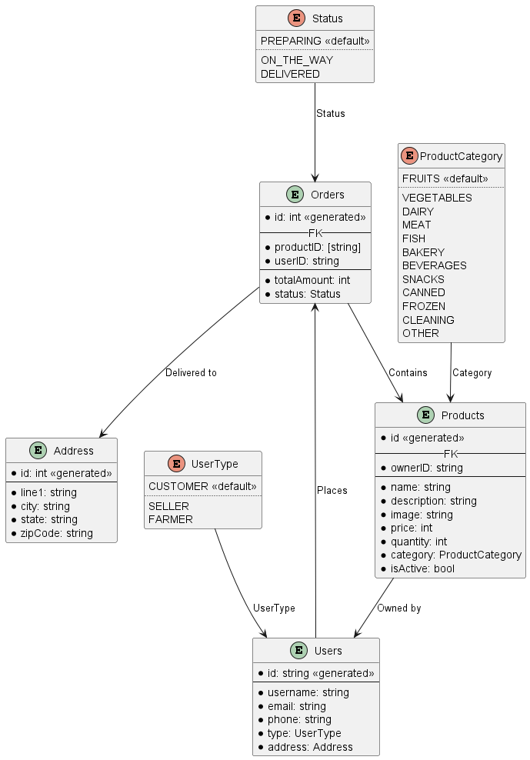

## FLOWCHART

## 

## 

**CHAPTER 4**

# RESULTS

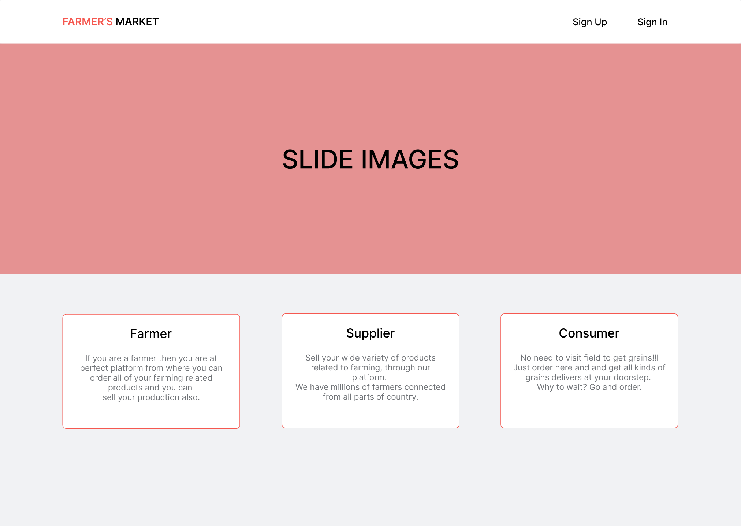

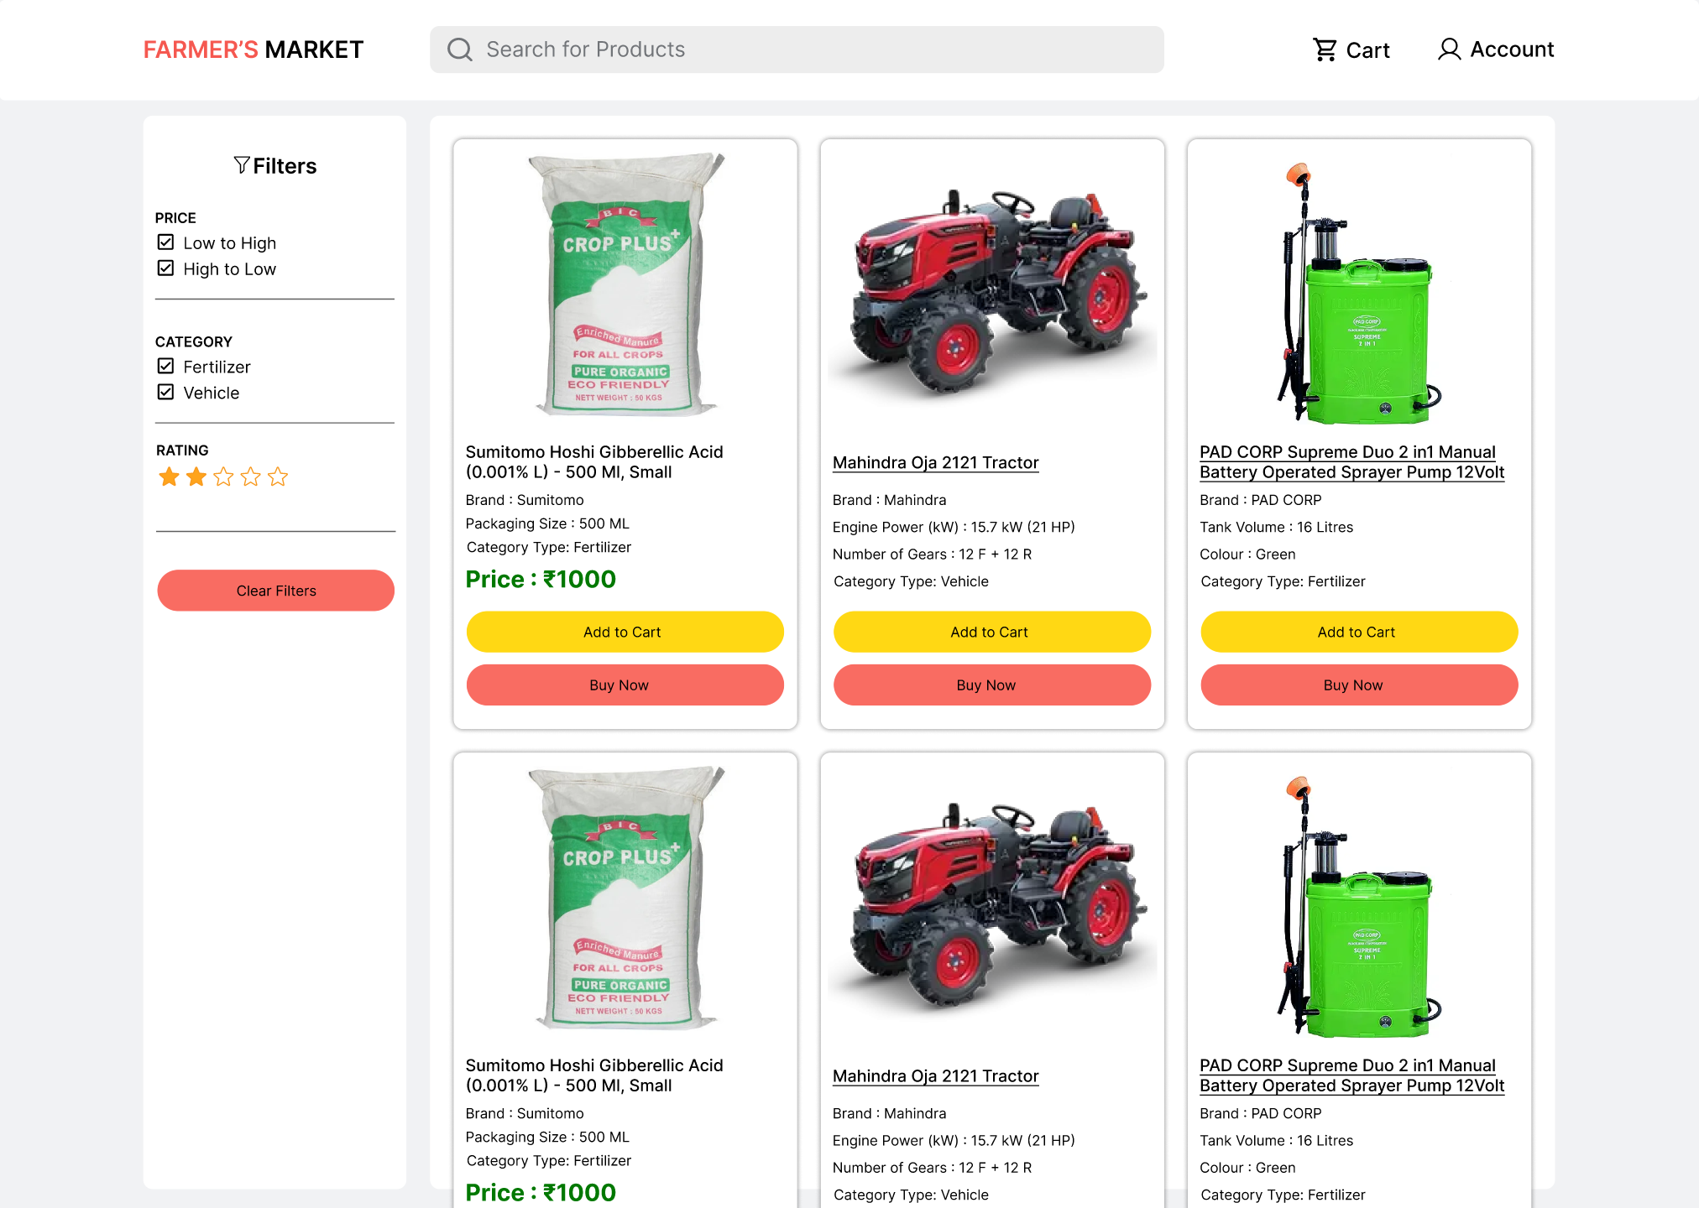

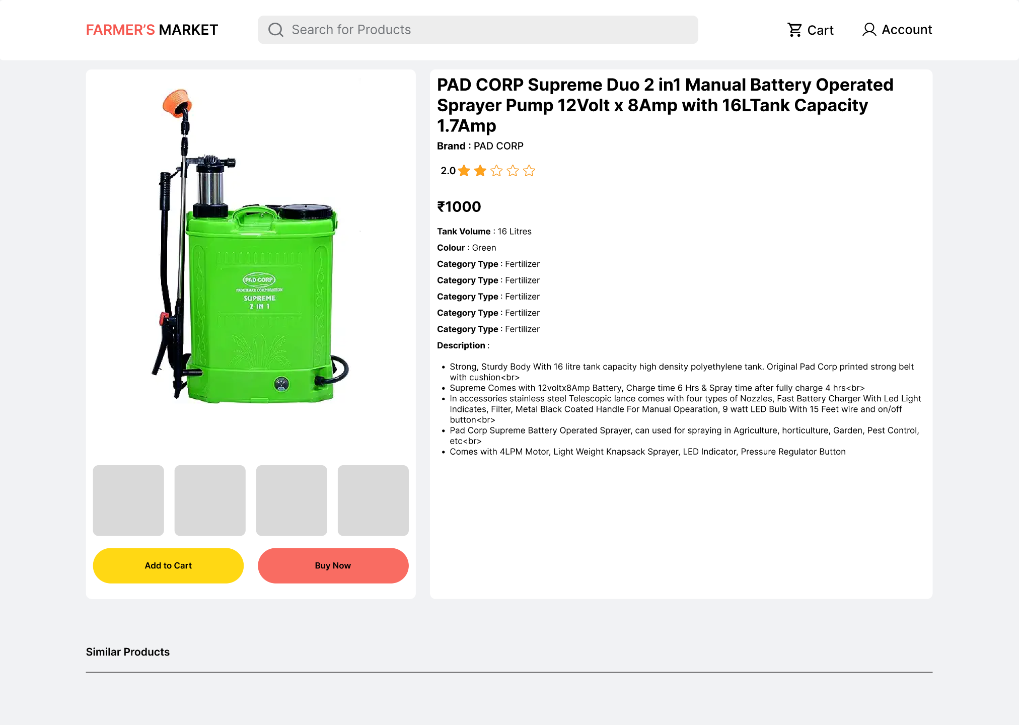

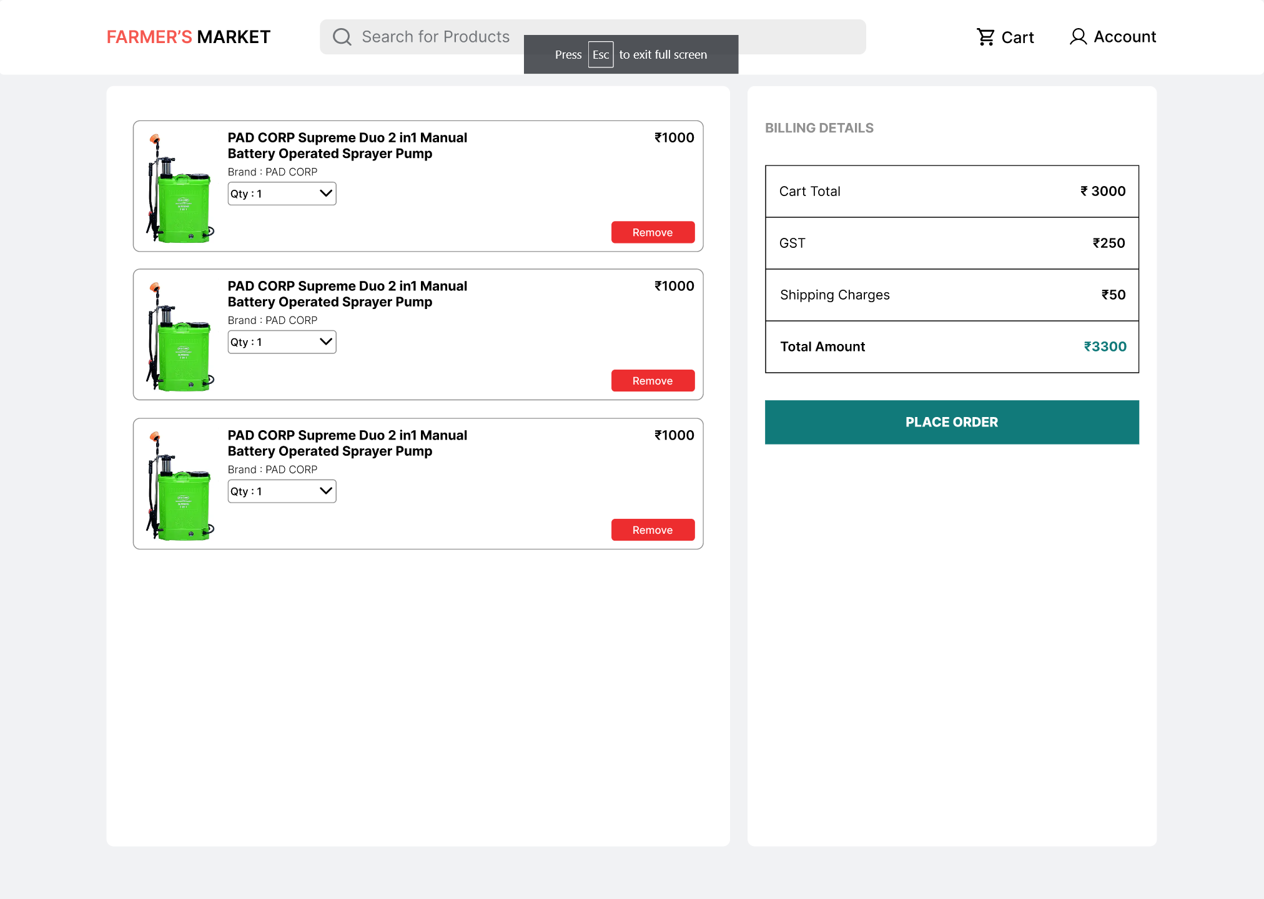

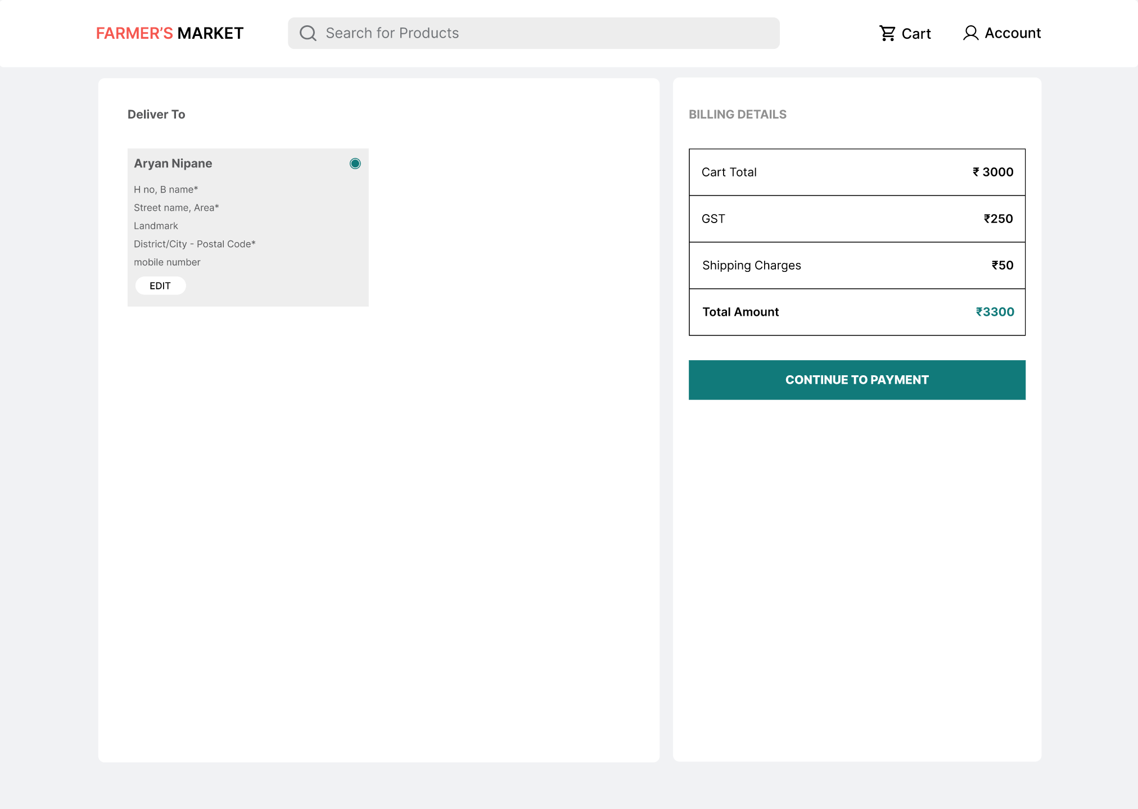

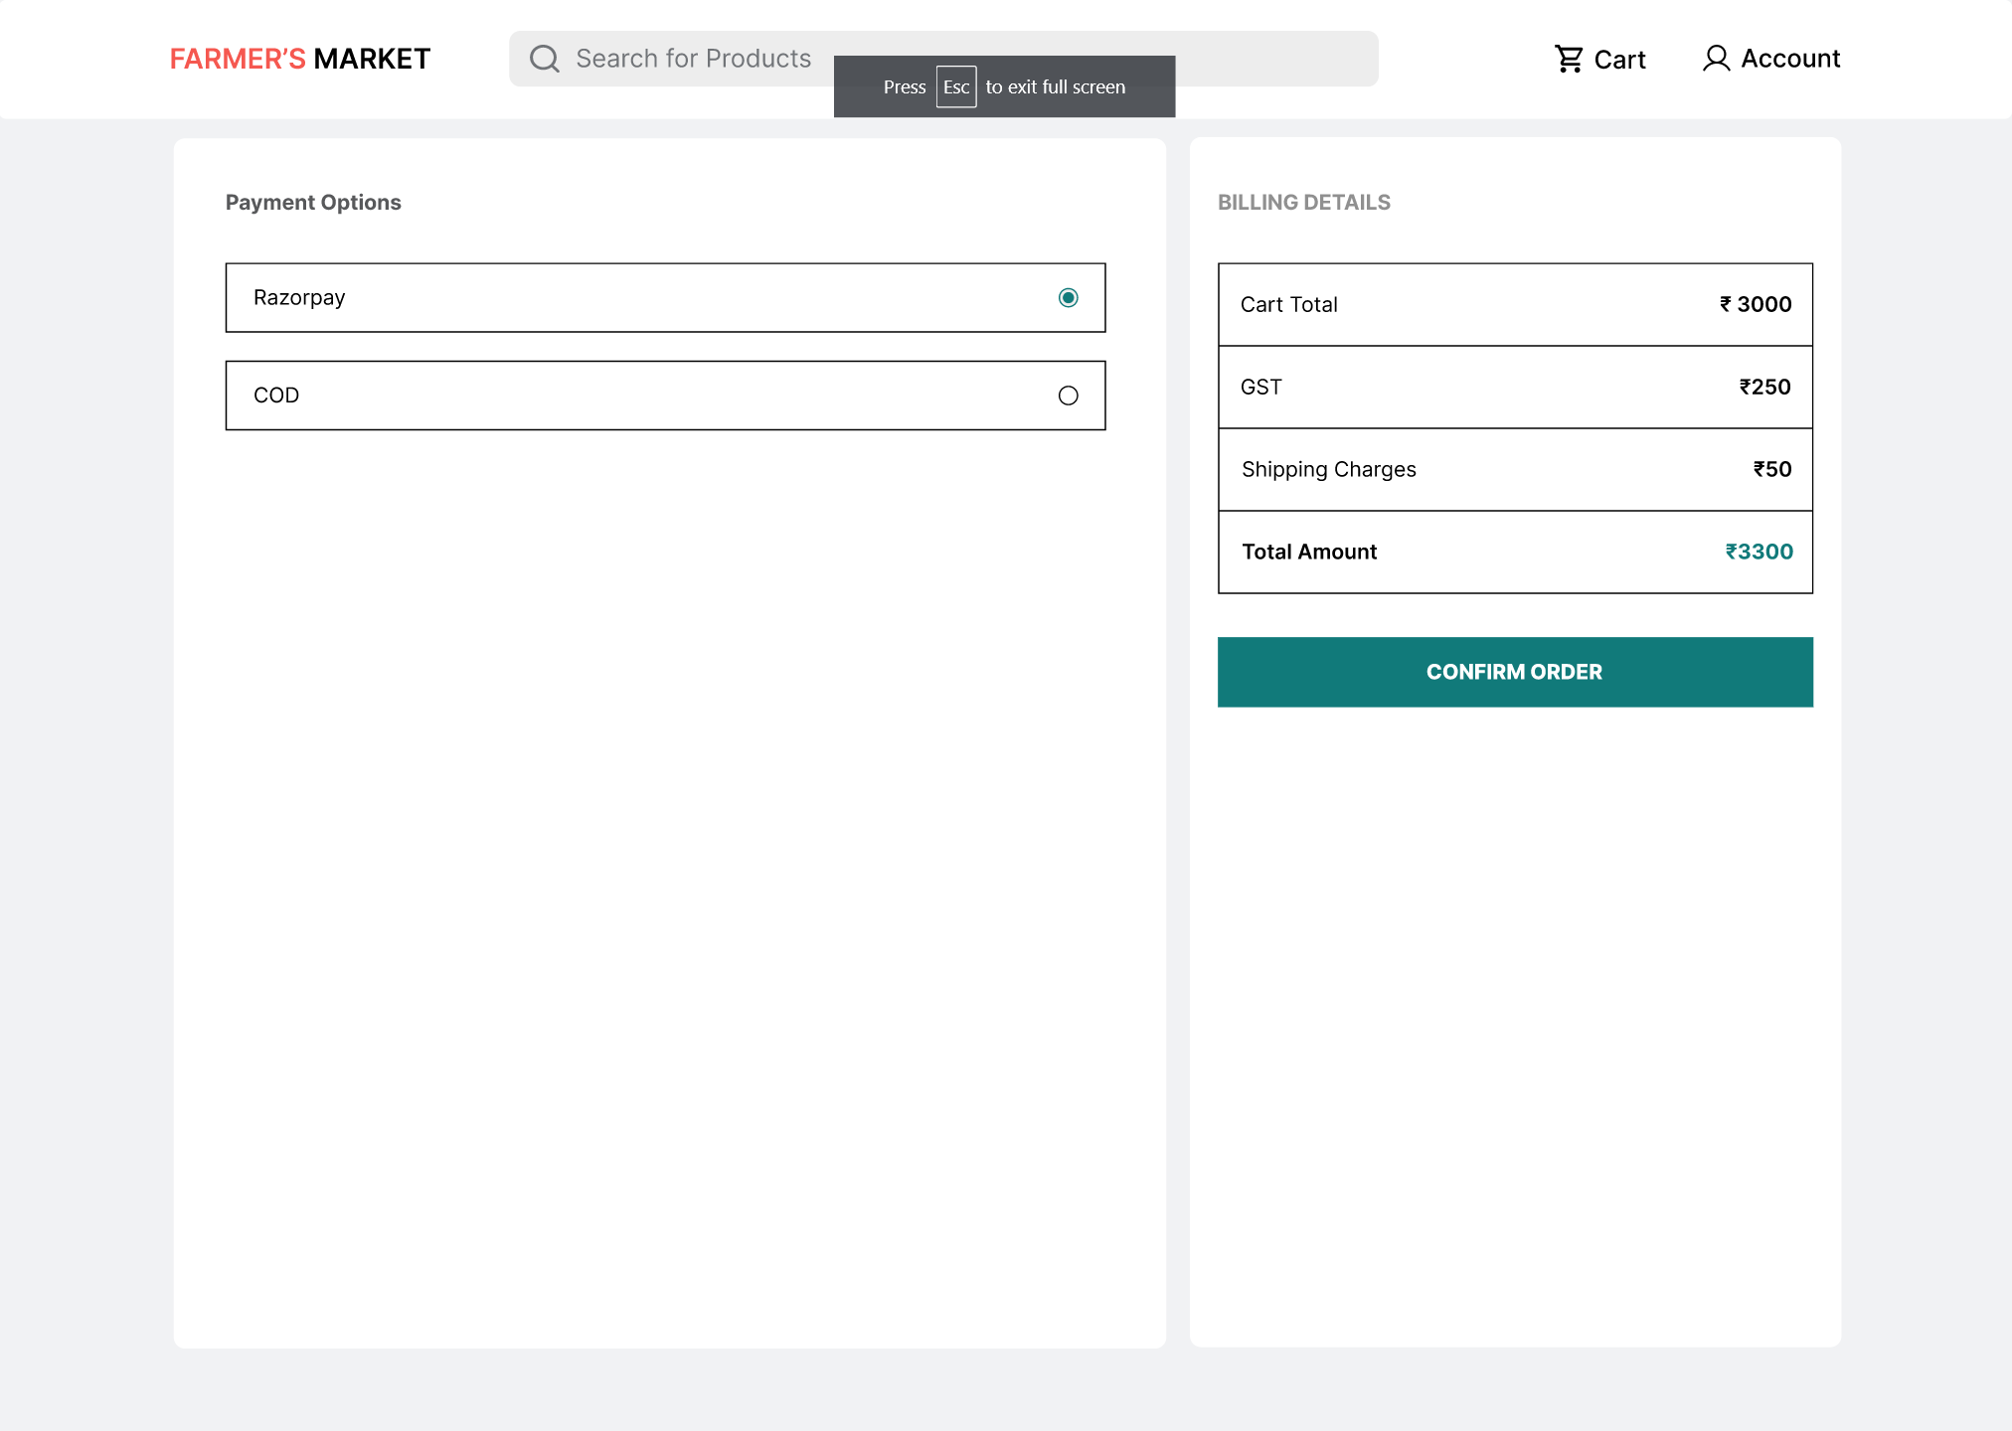

## APPLICATIONS

1. 1. Agricultural Product Exchange:
   * The primary application of the platform is to serve as an online marketplace for agricultural products. Farmers can list and sell their produce directly to consumers, offering fresh and locally-sourced items, including fruits, vegetables, dairy products, meat, and more.
2. 2. Livestock Trading:
   * The platform accommodates the trading of livestock, enabling farmers to sell animals directly to consumers. This application extends to livestock auctions, breeding stock sales, and the purchase of farm animals for various purposes.
3. 3. Agricultural Supplies and Equipment:
   * Sellers can market and sell agricultural supplies, equipment, and machinery to farmers. This aspect of the platform supports efficient farming practices by providing access to essential resources.
4. 4. Direct Sales of Specialty Products:
   * The platform can be utilized to promote and sell specialty agricultural products, such as organic produce, artisanal goods, and unique local offerings, directly to consumers who seek these items.
5. 5. Subscription Services:
   * Farmers can offer subscription services for regular delivery of agricultural products to consumers, ensuring a steady source of income for farmers and a convenient shopping experience for consumers.
6. 6. Agricultural Tourism and Experiences:
   * Farmers can promote and sell agricultural experiences, such as farm tours, workshops, and agritourism activities, directly to interested consumers.
7. 7. Sustainability Initiatives:
   * The platform can encourage sustainable farming practices by connecting consumers with farmers who prioritize eco-friendly and ethical production methods.
8. 8. Support for Local and Small-Scale Agriculture:
   * The platform can particularly benefit local and small-scale farmers by providing them with a direct and cost-effective means of reaching a broader consumer base.
9. 9. Agricultural Education and Workshops:
   * Farmers and agricultural experts can offer educational materials, workshops, and consulting services directly to consumers interested in improving their agricultural knowledge and practices.
10. 10. Community Building:
    * The platform can foster a sense of community and trust by connecting consumers with the farmers and sellers who produce the food they consume. This engagement can lead to stronger local food networks.
11. 11. Market Research and Data Analysis:
    * The platform generates data that can be valuable for market research and analysis in the agricultural sector, helping stakeholders make informed decisions.

## RESULT

The implementation of the web platform, designed to foster direct interactions among farmers, consumers, and sellers in the agricultural market, has produced a transformative impact across multiple dimensions. A prominent result has been the significant economic empowerment of farmers. Through the elimination of intermediaries, farmers can now secure a greater share of the profits from their agricultural products. This surge in income not only enhances the financial sustainability of farmers but also propels the adoption of sustainable farming practices. This dual impact elevates the agricultural sector's overall economic health and ecological consciousness.

Conversely, consumers have reaped the benefits of this direct-to-consumer model. The platform offers consumers unfettered access to fresh, locally-sourced produce, including a rich array of fruits, vegetables, dairy products, and meats. This newfound accessibility has kindled a transformation in consumer choice, fostering healthier consumption habits and strengthening the bond between consumers and their food sources. It not only encourages support for local farmers but also fuels a broader shift towards an ethically and ecologically responsible approach to food consumption.

Moreover, the platform has catalyzed a streamlined and transparent agricultural supply chain. By reducing the complexities tied to intermediaries, the platform has streamlined transactions and enhanced supply chain transparency. Furthermore, the platform serves as a catalyst for farmers to promote sustainable and eco-conscious farming practices. This not only spurs the growth of sustainable agriculture but also empowers consumers to actively endorse and support such practices, fostering a more responsible and ethically aware agricultural landscape. In sum, the implementation of this web platform has triggered a cascading transformation, benefiting farmers, consumers, and the agricultural sector as a whole.

## CHAPTER 5 CONCLUSION AND FUTURE WORKS

### CONCLUSION

The implementation of the web platform designed to connect farmers, consumers, and sellers within the agricultural market has ushered in a new era of efficiency, transparency, and sustainability in the sector. Through direct transactions, economic empowerment for farmers, and improved consumer access to fresh, local produce, the platform has transformed the way agricultural products are exchanged. Furthermore, the streamlined supply chain, support for sustainable farming practices, and the fostering of community connections have laid the foundation for a more robust and responsible agricultural ecosystem. The diverse applications of the platform provide a dynamic framework for addressing various agricultural needs and interests. It is evident that this platform has contributed to the betterment of the agricultural sector, offering a glimpse into the future of a more efficient and sustainable agricultural landscape.

### FUTURE WORKS

While the web platform can achieve remarkable success, there are several avenues for future work that can further enhance its impact and versatility. These include:

1. Enhanced Data Analytics: Expanding data analytics capabilities can provide more insights into market trends, consumer preferences, and sustainability metrics. This data can inform decision-making and help stakeholders make more informed choices.

2. International Expansion: Extending the platform's reach to international markets can create new opportunities for farmers and consumers while promoting global sustainability practices.

3. Blockchain Integration: The integration of blockchain technology can further enhance transparency in the supply chain, fostering trust and traceability for consumers and supporting fair trade practices.

4. Mobile Applications: Developing dedicated mobile applications can improve user experience and accessibility, allowing for real-time updates and transactions on the go.

5. Educational Initiatives: Expanding educational materials and workshops on the platform can help consumers and farmers gain more knowledge about sustainable farming practices and environmentally responsible consumption.

## CHAPTER 6 REFERENCES

*[1]* [*https://ieeexplore.ieee.org/document/8697615*](https://ieeexplore.ieee.org/document/8697615) *Digital Market: E-Commerce Application For Farmers by Manisha Bhende, Mohini S. Avatade, Suvarna Patil, Pooja Mishra, Pooja Prasad, Shubham Shewalkar*

*[2]* [*https://www.researchgate.net/publication/357759181_Crop_prediction_using_machine_learning*](https://www.researchgate.net/publication/357759181_Crop_prediction_using_machine_learning/link/61de828b034dda1b9eef2db0/download) *Crop prediction using machine learning by Madhuri Shripathi Rao, Arushi Singh, N.V. Subba Reddy and Dinesh U Acharya*

*[3]* [*https://ieeexplore.ieee.org/document/9725901*](https://ieeexplore.ieee.org/document/9725901) *Soil Analysis and Crop Recommendation using Machine Learning by Aditya Motwani, Param Patil, Vatsa Nagari, Shobhit Verm, Sunil Ghane*

*[4]* [*https://www.pmkisan.gov.in/*](https://www.pmkisan.gov.in/)

*[5]* [*https://www.myscheme.gov.in/*](https://www.myscheme.gov.in/)

*[6]* [*https://www.mongodb.com/docs/*](https://www.mongodb.com/docs/)

*[7]* [*https://expressjs.com/en/5x/api.html*](https://expressjs.com/en/5x/api.html)

*[8]* [*https://react.dev/learn*](https://react.dev/learn)

*[9]* [*https://nodejs.org/en/docs*](https://nodejs.org/en/docs)